Exercise 8
- How many unique salary packages does our company, Bignet, offer? List them in descending order.
Answer: SELECT DISTINCT salary
FROM employee_data
ORDER BY salary DESC;

SELECT COUNT(DISTINCT salary) AS unique_salary_count
FROM employee_data;

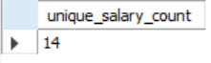

- How many distinct first names do we have in our database?
Answer: SELECT COUNT(DISTINCT f_name) AS distinct_first_names
FROM employee_data;

